**CO2 PYTHON PROGRAMS**

1. Program to find the factorial of a number.

**Program**

n=int(input("Enter the limit: "))

f=1

for i in range(1,n+1):

f=f*i

print("Factorial of number :",f)

**Output**



2. Generate Fibonacci series of N terms.

**Program**

n=int(input("Enter the limit: "))

a=0

b=1

sum=0

count=1

print("Fibonacci series: ",end="")

while(count<=n):

print(sum,end=" ")

count=count+1

a=b

b=sum

sum=a+b

**Output**



3. Find the sum of all items in a list.

**Program**

list=[10,20,30]

n=sum(list)

print("Sum=",n)

**Output**



4. Generate a list of four digit numbers in a given range with all their digits even and the number is a perfect square.

**Program**

from math import sqrt as s

for i in range(1000,10000):

if s(i)==int(s(i)) and i%2==0:

print(i,end=" ")

**Output**



5. Display the given pyramid with step number accepted from user.

**Program**

rows = int(input("Enter the number of rows: "))

for i in range(1, rows+1):

for j in range(1,i+1):

print(i * j, end=' ')

print()

**Output**

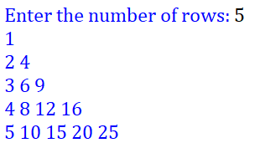

6. Program to count the number of characters (character frequency) in a string.

**Program**

test_str=str(input("Enter the string : "))

freq = {}

for i in test_str:

if i in freq:

freq[i] += 1

else:

freq[i] = 1

print ("Count of all characters : "+ str(freq))

**Output**



7. Program to add ‘ing’ at the end of a given string. If it already ends with ‘ing’, then add ‘ly’.

**Program**

str=input("enter a string:")

print("inputed string is:",str)

if(str.endswith("ing")):

str=str+'ly'

else:

str=str+'ing'

print("the formated string is:",str)

**Output**

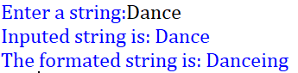

8. Accept a list of words and return length of longest word.

**Program**

a=[]

n= int(input("Enter the number of elements in list:"))

for x in range(0,n):

element=input("Enter element "+ str(x+1)+": " )

a.append(element)

max1=len(a[0])

temp=a[0]

for i in a:

if(len(i)>max1):

max1=len(i)

temp=i

print("Longest Word:",temp)

print("Length of longest word :",max1)

**Output**

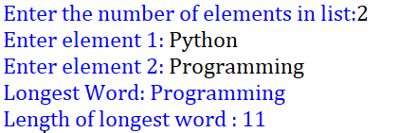

9. Construct following pattern using nested loop

**Program**

n=int(input("Enter the limit: "))

for i in range(n):

for j in range(i):

print("*",end=" ")

print("")

for i in range(n,0,-1):

for j in range(i):

print("*",end=" ")

print(" ")

**Output**

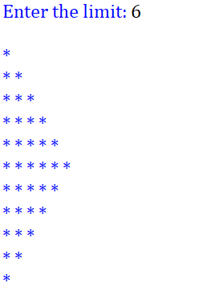

10. Program to generate all factors of a number.

**Program**

def factor(x):

print("The factors of", x,"are: ")

for i in range(1,x+1):

if(x%i==0):

print(i)

n=int(input("Enter a number: "))

factor(n)

**Output**

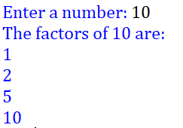

11. Write lambda functions to find area of square, rectangle and triangle.

**Program**

import math

t_area=lambda b,h:1/2*b*h

r_area=lambda l,b:l*b

s_area=lambda a:a*a

print("Area of triangle:",t_area(10,20))

print("Area of recangle:",r_area(30,20))

print("Area of square:",s_area(15))

**Output**

